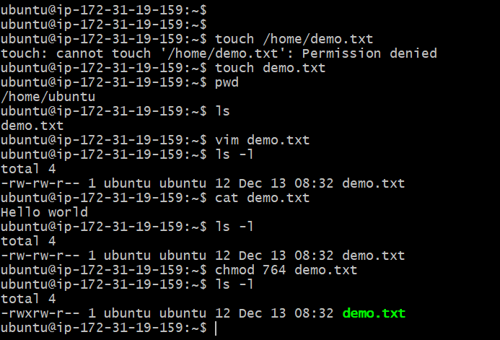
- Create a file with name demo.txt
- Gave permission as instructed.

